Project Management Plan Version 1.0
Date

Project Name:
Coursework Management System
Introduction/Overview of Project

The project aims to build a new Handin system for the school of Electronic and Computer Science. This system mainly consists of two parts, one is the submission side and the other is the feedback side. Supports individual assignments and group assignments on the submission side. Submissions support multiple assignments contain text, code, etc. And display relevant coursework information (including start time, end time, etc.). On the feedback side, teaching assistants can view the submitted assignments and give feedback, and give corresponding scores according to the scoring standards. And the teaching team or the administrator can check the homework submission status of the corresponding students and export the results. containing the list of students, delays, and final marks for each course element.

Project Organization
Team members: Betty T, Ziliu W Aryaman T. Mingdong Qiu
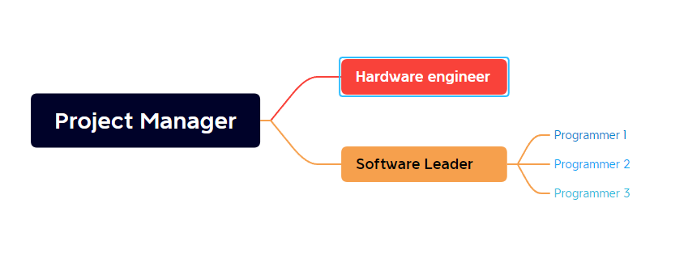

Management and Technical Processes
Management Processes:
Planning, evaluate the different alternatives and choose the best from them.
Organizing, define the group's functions, establish relationships and defining authority and responsibility
Staffing, recruitment or placement and selection or training takes place for the development of members in the firm
Directing, is to give the Direction to the employees.
Controlling,Controlling involves ensuring that performance does not deviate from standards.
Coordination, it ensures that different departments and groups work in sync.

Technical Processes:
Stakeholder Requirement definition:
A coursework management system include submission side and feedback side. Academics can view students’ submission and give feedback.
Requirement analysis
1. Academic can define new coursework for a module in current semester.
2. A module can have zero, one or more coursework.
3. Coursework can be individual or group coursework.
4. Coursework has a specification and marking criteria.
5. if it is group coursework a list of students is attached to it
6. Indicate data like publication date, deadline, etc.
7. support multi piece of submission.
8. academic can view and add feedback and mark.
9. a member of the teaching team can release individual feedback or the results for the whole cohort at once.
10. The teaching and admin team then can see several reports.
11. Export a spreadsheet file containing the list of students, delays, and final marks for each course element.
Architecture design
(todo)

Implementation
The Implementation process is comprised of two primary efforts:
- Design
- Realization
The outputs of the Implementation process include:
- The detailed design, down to the lowest level system elements in the system architecture
- The fabrication procedures of forming, joining and finishing, or coding for software
Test

Design test planning according to the requirement
Test case design and development.
Test environment setup.
Test execution.
Test cycle closure
Finish

Work to Be Performed

scope of work

Schedule Information

Budget Information
130,000￡

References to Other Project Planning Documents
Activity list and attributes
Activity resource requirements
Assumption log
Breakeven
Business case
Change requirement
Charter
Communication management plan
Contract closure notice
Contract statement of work
Contract
Cost baseline
Cost estimate

